Name: Muhammad Yar
Course: CEH (Certified Ethical Hacker)
Submitted To: Sir Salman

Lab Assignment

Title: Installation and Configuration of Kali Linux on VMware

Objective:
To download Kali Linux ISO and configure it as a virtual machine using VMware for cybersecurity and ethical hacking practice.

Requirements:
Processor: 64-bit Intel i3/i5/i7 or AMD equivalent
RAM: 4 GB minimum (8 GB recommended)
Storage: At least 40 GB free space
Virtualization: Enabled in BIOS

Software Required:
Kali Linux ISO file
VMware Workstation

Steps:

Step 1: Download Kali Linux ISO File
Go to official website: https://www.kali.org/get-kali/
Download Installer ISO
Screenshot:
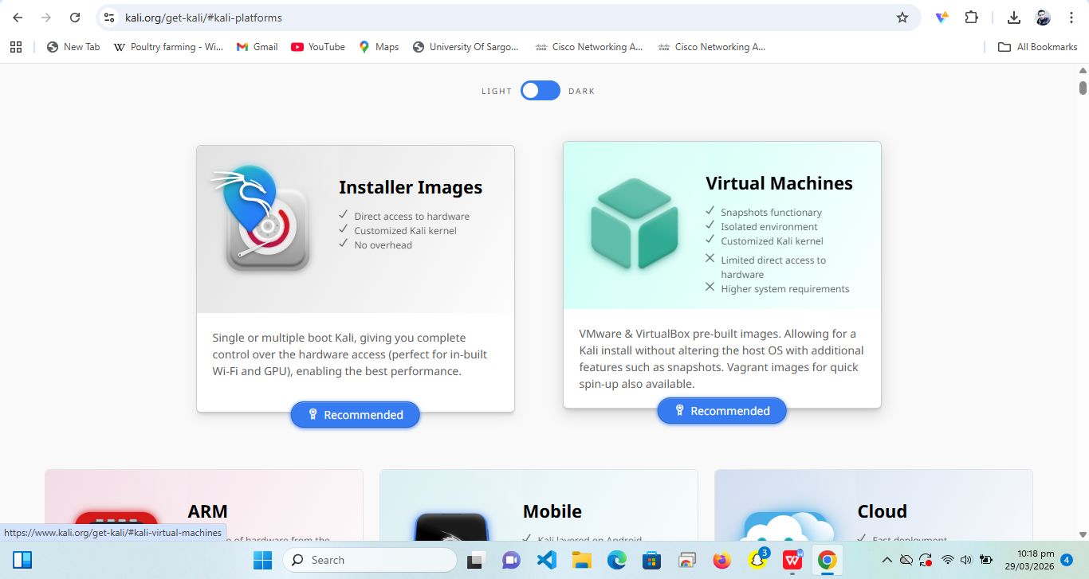

Step 2: Download VMware Workstation
Go to official website: https://www.vmware.com/products/workstation-player.html
Download VMware Workstation Player
Screenshot: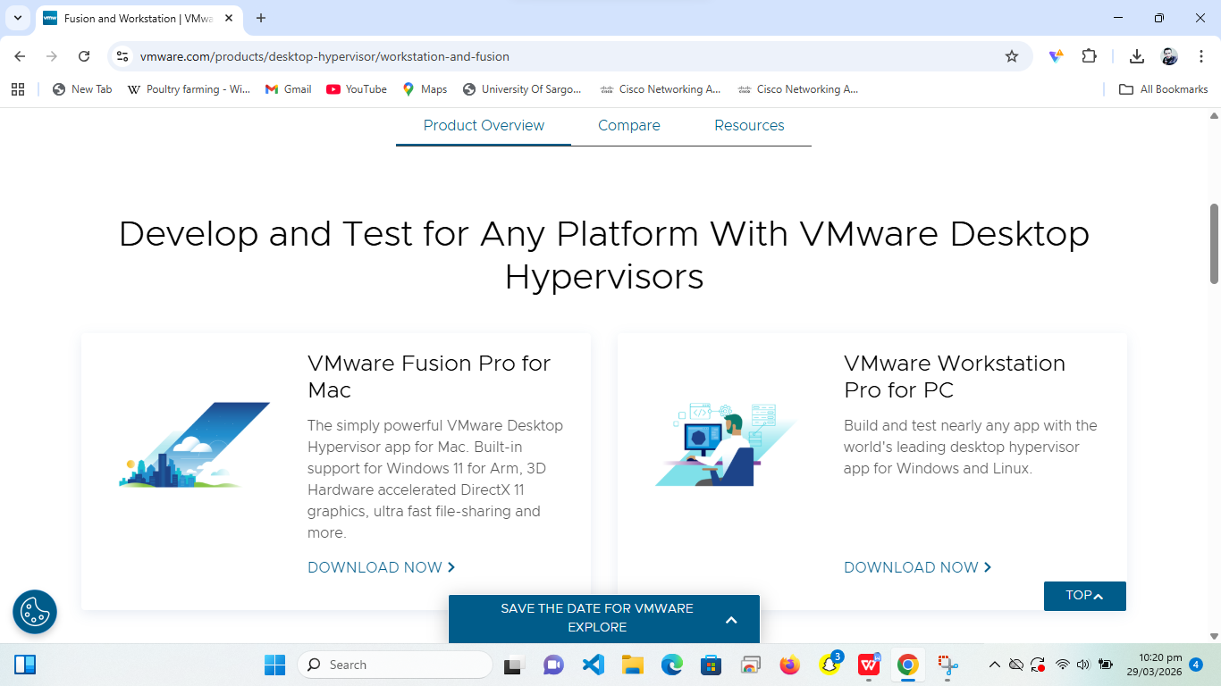

Step 3: Install VMware
Run setup → Next → Install → Finish

Step 4: Create New Virtual Machine
Open VMware → Create New VM → Select ISO file
Screenshot:
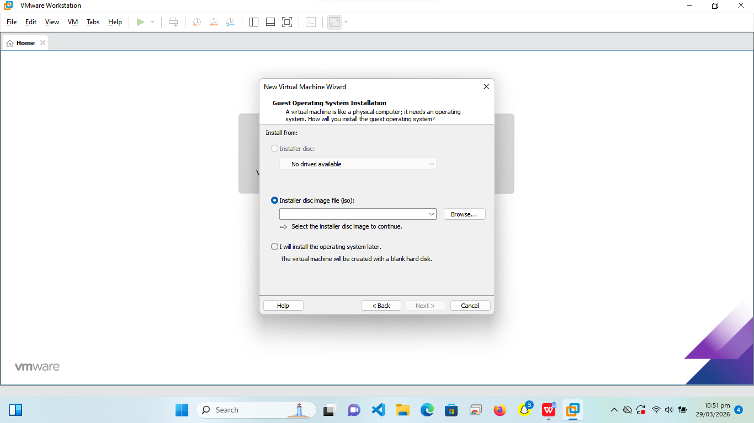

Step 5: Select OS
Choose Linux → Debian 64-bit
Screenshot:
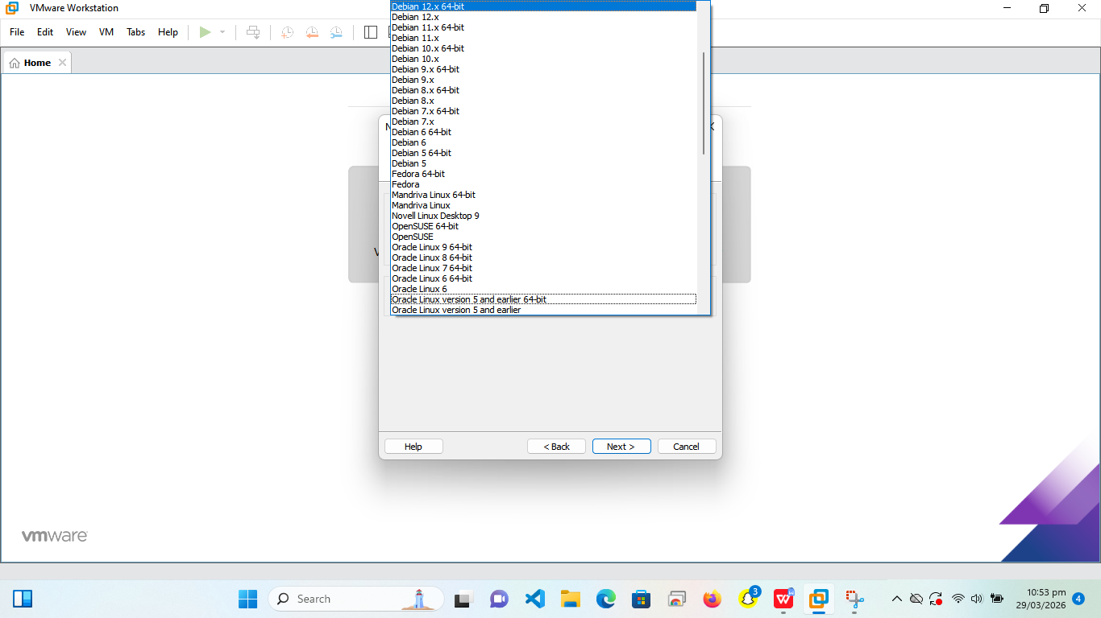

Step 6: Name VM
Name: Kali Linux → Choose location
Screenshot:
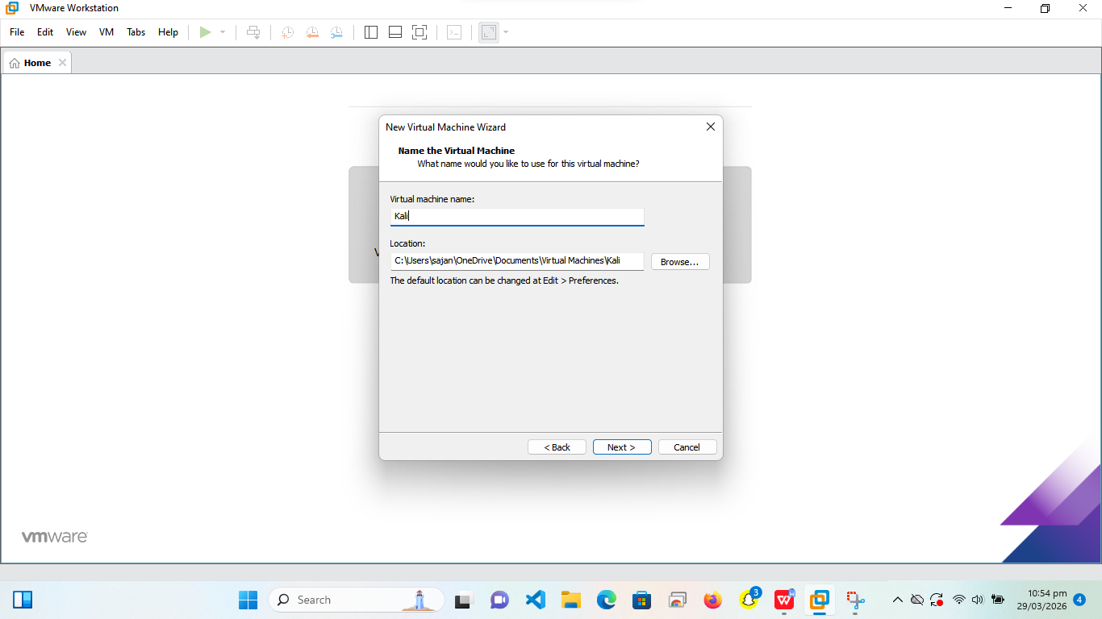

Step 7: Disk Size
Set 20–40 GB → Single file
Screenshot:
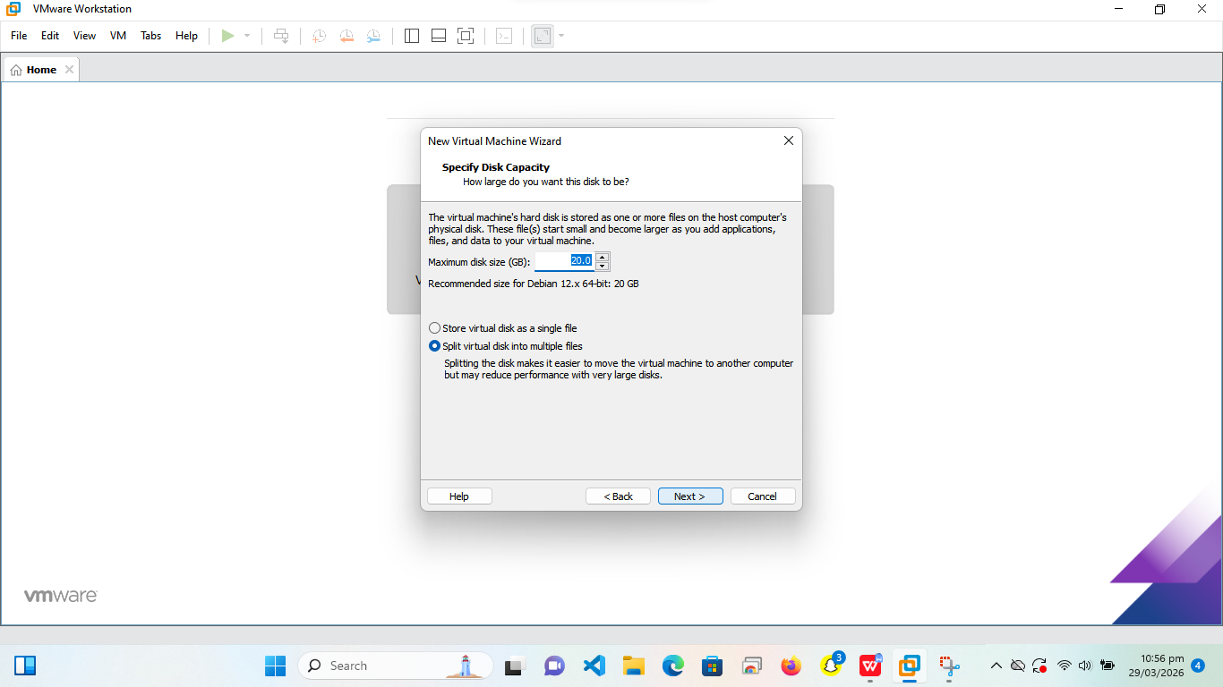

Step 8: Customize Hardware
RAM: 4–8 GB, CPU: 2 cores, Network: NAT
Screenshot:

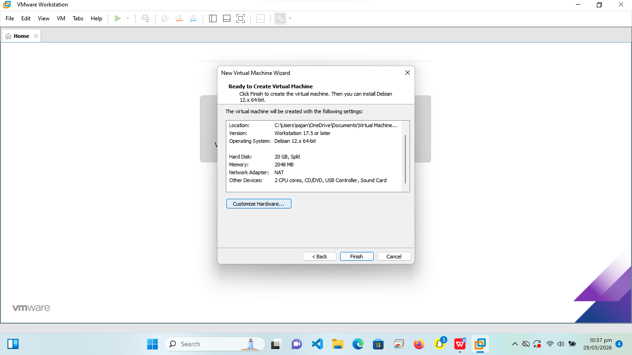

Step 9: Start VM
Power on virtual machine
Screenshot:
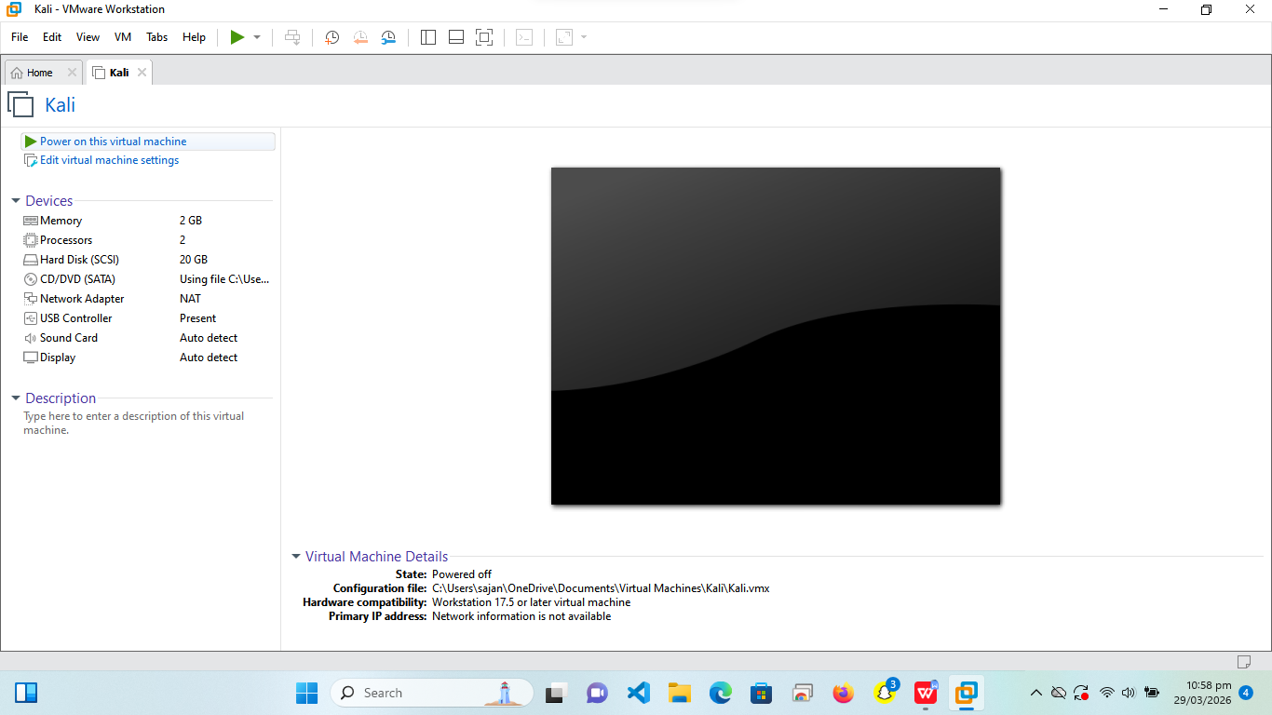

Step 10: Install Kali Linux
Select Graphical Install → Configure settings
Screenshot:

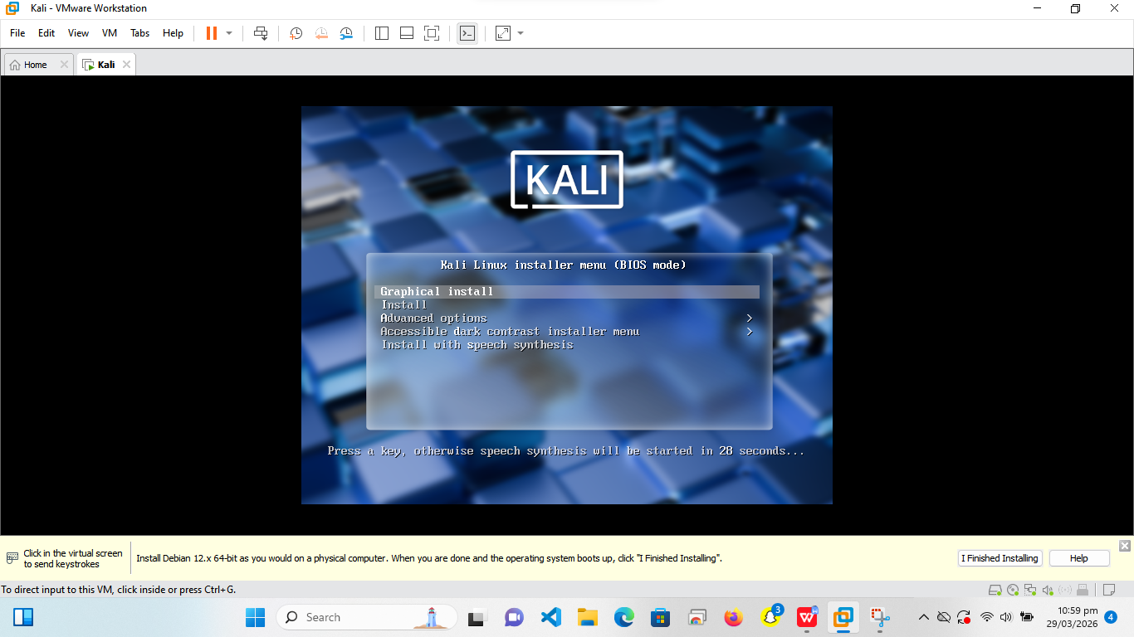

Step 11: Set User Credentials
Enter username and password
Screenshot: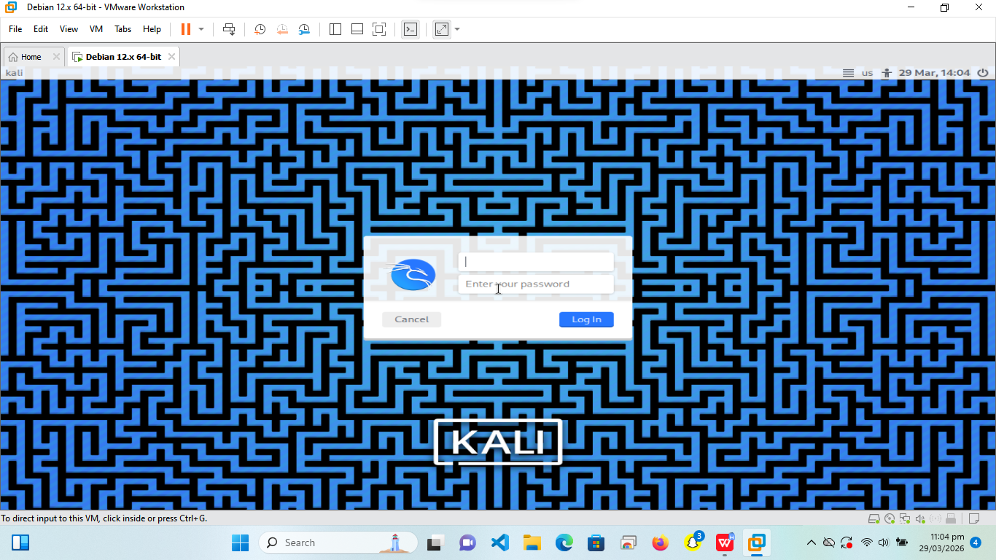

Step 12: Complete Installation
Wait until installation finishes
Screenshot:
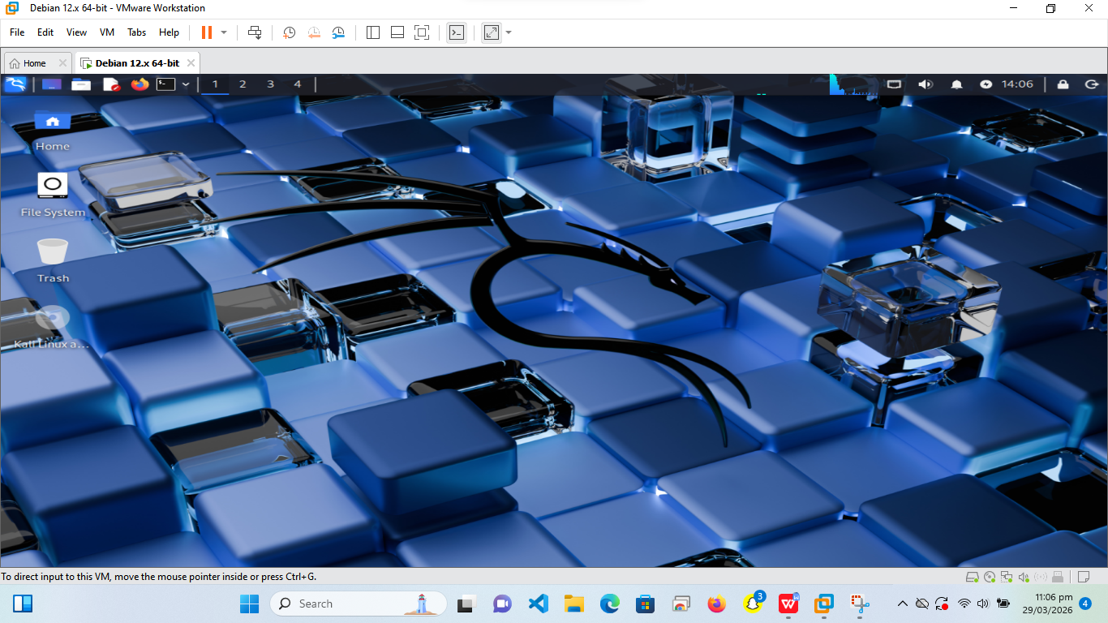

Result:
Kali Linux installed successfully on VMware and ready for cybersecurity labs.

